**21/09/2021 CD LAB 3 2019103573**

**EXCERSISES**

**1.Write a lex program to identify whether a given symbol is operator symbol or not and** **identify its token name.**

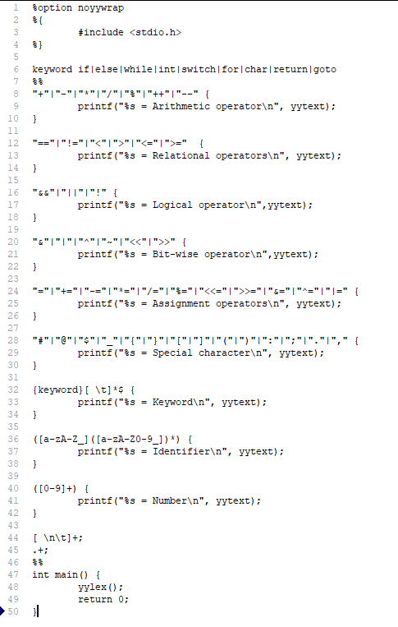**Code :**

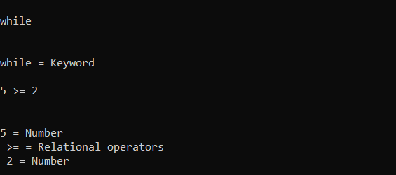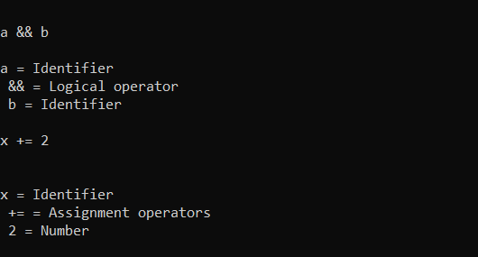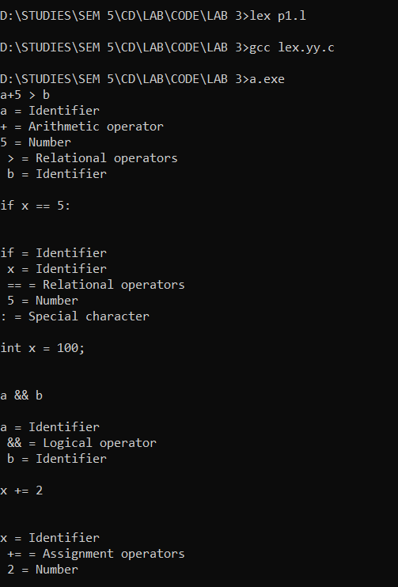**Output :**

**2.Write a lex program to identify whether a given line is a comment or not.**

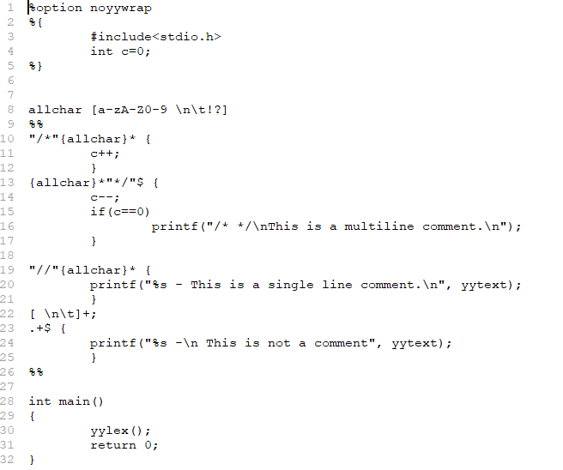**Code :**

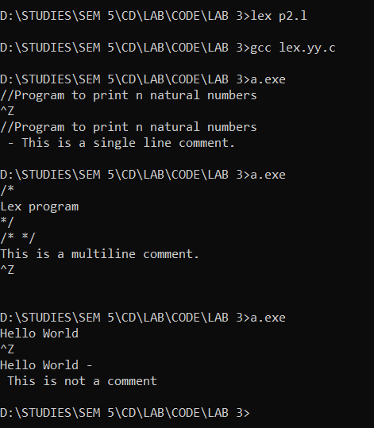**Output :**



**3.Write a lex program to recognize strings under 'a*', 'a*b+', 'abb'.**

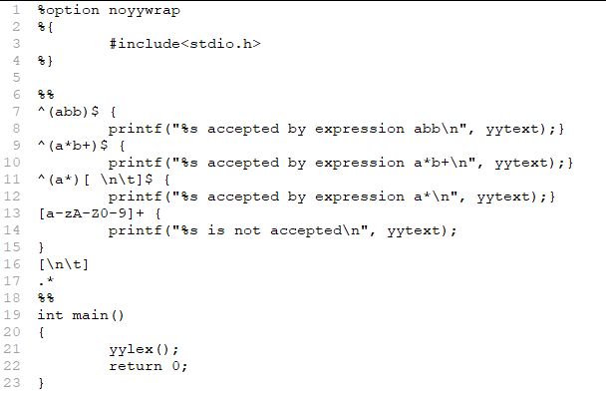**Code :**

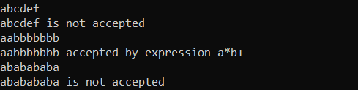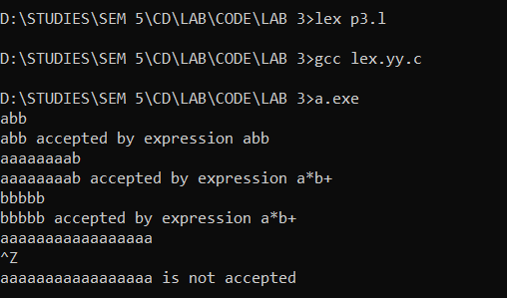**Output :**